chapter 5

Risk assessment & Plan for

the proof of concept

In this chapter you will plan the next step of the project in which you will develop a proof-of-concept prototype. The main objective of a proof-of-concept is to determine the solution to some technical problem, such as how two systems might be integrated or that a certain throughput can be achieved with a given configuration. A proof-of-concept can be a partial solution that involves a limited amount of functionality and scope to establish whether the system satisfies some aspect of the requirements and to test various implementation options. It is also meant for you to become acquainted with the technologies and form opinions on how to use them best in the final system design. Specifically, when describing the planned prototype (and when presenting it later), make sure to convince the reader how the prototype is expected to give:

• Better understanding of requirements;

• Understanding of the capabilities and limitations of new technologies;

• The ability to assess design decisions early in the process;

• The ability of the customer to visualize the look-and-feel of the final solution;

• And, most impotently: reduction of the risk of project failure.

**Chapter 5: Risk Assessment & Plan for the Proof of Concept**

**Overview**

To assess the risks in our system’s design, we must break down each functionality and analyze it individually. This process will deepen our understanding of the design and allow us to explore a broader range of implementation options for our current high-level system architecture.

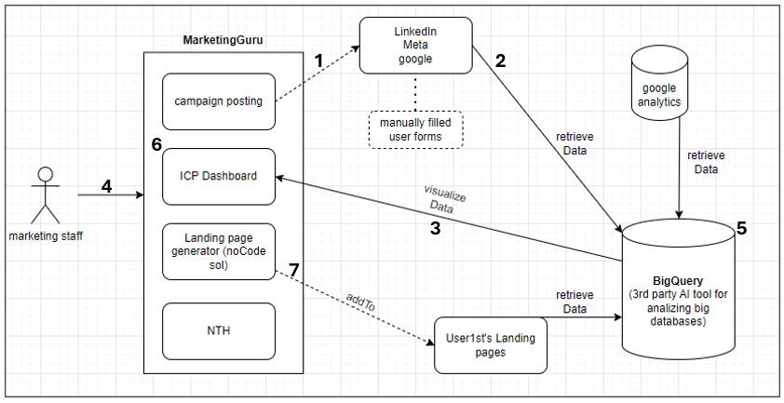

In this chapter, we’ll focus on the seven main bottlenecks in our design. The goal here is to create a proof-of-concept (PoC) prototype that tackles each bottleneck separately, testing how well our components work together—things like campaign posting across platforms, pulling in data from LinkedIn and Google Analytics, and visualizing it in the ICP Dashboard. The PoC will let us experiment with limited functionality to see if we can solve specific technical challenges, especially around data management, visualization, and security.

Building this PoC will give us a clearer sense of what’s needed, help us understand the limitations and strengths of tools like BigQuery, and allow us to make smarter design choices upfront. We’ll outline test cases for each bottleneck, covering happy, sad, and bad paths, to show how the PoC will reduce project risks. Ultimately, this step will help us get a real feel for what the final system might look like and build confidence in the design before diving into full development.



|  |  |  |
| --- | --- | --- |
| **Risk Category** | **Risk Description** | **Mitigation Strategy** |
| **Integration for Cross-Platform Posting** | Difficulty in implementing simultaneous posting across LinkedIn, Meta, and Google. | Test each platform individually in the PoC to resolve compatibility issues before full integration.  **Test using** platform-specific API calls and logging responses. |
| **Data Retrieval Challenges** | Difficulty in retrieving data from LinkedIn, Meta, Google Analytics, and other sources. | Establish connections to each source in the PoC to confirm data access and permissions.  **Test using** API response verification for each source and error handling for permission issues. |
| **Data Presentation and Visualization** | Difficulty in presenting data clearly for marketing teams, especially using Looker. | Create basic Looker visualizations in the PoC; gather feedback to refine dashboard functionality.  **Test using** sample data visualizations and feedback from end-users on usability and clarity. |
| **Data Privacy and Security** | Risk of handling personal user information securely. | Set up basic encryption and access controls in the PoC; test role-based permissions, third-party authentication mechanism (googleAuth, Facebook Login..)  **Test using** simulated access attempts by different roles and check for unauthorized data access attempts. |
| **Complexity of Working with BigQuery** | Learning curve and complexity in setting up BigQuery. | Run a small dataset through BigQuery in the PoC; familiarize team with its features.  **Test using** simple queries on sample data to assess performance and data handling efficiency. |
| **Challenges in Identifying ICP** | Difficulty in accurately identifying the Ideal Customer Profile (ICP). | Test ICP detection on sample data; refine methodology iteratively.  **Test using** sample customer data, analyzing ICP algorithm accuracy and refining based on results. |
| |  | | --- | | **Implementing a NoCode Solution for Landing Pages** |  |  | | --- | |  | | |  | | --- | | Challenges in building a flexible, user-friendly no-code tool for landing page creation. |  |  | | --- | |  | | Develop a basic no-code prototype in the PoC to test functionality and gather user feedback on usability.  **Test using** sample landing page builds and collect feedback from non-technical users. |

**Plan for the Proof of Concept**

Our PoC will validate the core components of "MarketingGuru" in a manageable, phased approach. Each phase targets specific high-risk areas, so we can address potential blockers early. Given our team of four developers, I’ve outlined the necessary resources and time for each step.

**Phase 1: Integration for Cross-Platform Posting**

**Objective:** Verify that we can post campaigns simultaneously across LinkedIn, Meta, and Google.

1. **Implement Individual Platform Posting**
   * **Steps:**
     + Start with a LinkedIn API integration.
     + Implement basic campaign posting functions (e.g., text posts, image uploads).
     + Repeat the process for Meta and Google.
   * **Testing:**
     + Use API response verification and logging to confirm successful posts.
     + Track potential issues with rate limits and incompatible formats.
   * **ETA:** 1 weeks
   * **Developers Required:** 2
2. **Combine Platforms for Simultaneous Posting**
   * **Steps:**
     + Develop a single function that can trigger campaign posting across all platforms.
     + Ensure API calls are synchronized and handle errors for each platform independently to avoid interruptions.
   * **Testing:**
     + Test simultaneous posting with small sample data.
     + Monitor for rate limit issues and API error handling.
   * **ETA:** 3 days
   * **Developers Required:** 2

**Phase 2: Data Retrieval Challenges**

**Objective:** Confirm our system can retrieve data from all sources (LinkedIn, Meta, Google Analytics, user forms) and consolidate it for use.

1. **Establish Data Retrieval for Each Source**
   * **Steps:**
     + Set up API connections for LinkedIn, Meta, Google Analytics, and user forms.
     + Build basic functions for retrieving data (e.g., campaign engagement metrics, user-submitted forms).
   * **Testing:**
     + Test each data retrieval function individually, verifying data integrity.
     + Confirm authentication and permissions for each source.
   * **ETA:** 1.5-2 weeks
   * **Developers Required:** 2-3
2. **Data Consolidation and Error Handling**
   * **Steps:**
     + Create a centralized function that consolidates data from all sources.
     + Develop error handling to manage data inconsistencies or missing fields.
   * **Testing:**
     + Test with mixed data from all sources, checking that data is accurately combined.
     + Simulate permission issues to verify error handling.
   * **ETA:** 1 week
   * **Developers Required:** 1

**Phase 3: Data Presentation and Visualization**

**Objective:** Use Looker to present consolidated data in a clear, actionable format.

1. **Set Up Looker Integration**
   * **Steps:**
     + Connect Looker to the PoC database containing consolidated data.
     + Build sample visualizations (e.g., engagement rates, campaign performance).
   * **Testing:**
     + Test visualizations using real data.
     + Collect feedback from the marketing team on the clarity and usability of visualizations.
   * **ETA:** 0.5-1 week
   * **Developers Required:** 1-2
2. **Refine Dashboard Based on Feedback**
   * **Steps:**
     + Adjust visualizations and add new metrics based on feedback.
   * **Testing:**
     + Validate that updates improve clarity and functionality.
   * **ETA:** 1 week
   * **Developers Required:** 1

**Phase 4: Data Privacy and Security**

**Objective:** Ensure data storage and access controls meet security standards, focusing on user privacy.

1. **Implement Basic Security Framework**
   * **Steps:**
     + Set up encryption for data storage.
     + Implement basic role-based access controls (e.g., admin vs. regular user).
     + Use third-party tool for authentication (GoogleAuth, Facebook Login… )
   * **Testing:**
     + Run tests with different roles to verify access permissions.
     + Confirm encryption functionality and check for unencrypted data leakage.
   * **ETA:** 1 weeks
   * **Developers Required:** 2
2. **Review and Stress-Test Security Protocols**
   * **Steps:**
     + Conduct internal security audits.
     + Simulate unauthorized access attempts to test system robustness.
   * **ETA:** 1 week
   * **Developers Required:** 2

**Phase 5: Complexity of Working with BigQuery**

**Objective:** Confirm BigQuery’s suitability for large-scale data processing, specifically for querying and analysis.

1. **Initial BigQuery Setup**
   * **Steps:**
     + Configure BigQuery with a sample dataset.
     + Develop queries to analyze key metrics (e.g., campaign reach, user engagement).
   * **Testing:**
     + Test queries for speed and accuracy.
     + Monitor performance with increasing dataset size.
   * **ETA:** 1 week
   * **Developers Required:** 1
2. **Optimize Query Performance**
   * **Steps:**
     + Experiment with different indexing and query optimization techniques.
   * **Testing:**
     + Benchmark query performance and refine based on test results.
   * **ETA:** 1 week
   * **Developers Required:** 1

**Phase 6: Implementing a NoCode Solution for Landing Pages**

**Objective:** Develop a simple no-code landing page generator to validate ease of use for non-technical users.

1. **Develop Basic No-Code Landing Page Creator**
   * **Steps:**
     + Create a drag-and-drop interface for landing page creation.
     + Include basic components like text, images, and call-to-action buttons.
   * **Testing:**
     + Conduct usability tests with marketing staff.
     + Collect feedback on functionality and ease of use.
   * **ETA:** 2 weeks
   * **Developers Required:** 2
2. **Refine Based on Feedback**
   * **Steps:**
     + Make improvements to the user interface and add any necessary features identified in feedback.
   * **Testing:**
     + Test updated features and confirm improvements in user experience.
   * **ETA:** 1 week
   * **Developers Required:** 2

**Phase 7: Challenges in Identifying ICP**

**Objective:** Test and refine algorithms for identifying the Ideal Customer Profile (ICP) from collected data.

1. **Preliminary ICP Detection Algorithms**
   * **Steps:**
     + Develop initial algorithms to identify customer profiles based on key metrics (e.g., engagement, demographics).
   * **Testing:**
     + Run algorithms on sample data to evaluate accuracy.
     + Analyze results for potential adjustments.
   * **ETA:** 2 weeks
   * **Developers Required:** 2
2. **Refine ICP Algorithms**
   * **Steps:**
     + Refine algorithms based on initial results, focusing on precision and relevance.
   * **Testing:**
     + Rerun tests and validate improvements in identifying meaningful customer profiles.
   * **ETA:** 1 week
   * **Developers Required:** 2